Relating with others in an acceptable way.

**Learning outcome:**

Identifying, taking interest and observing people around me.

**Competence:**

Observes and talks about people at home and learning centre e.g parents, children, maids, nannies, gate keeper, aunties, cousin, uncles, nephew, daughter

**Lesson (1)**

Father, mother, sister, brother, baby

**Suggested materials**

* Real people
* Pictures
* Visual aids

**Procedure:**

* Let the children recite the rhyme about people at home.

There there there,

There at home,

There is mummy,

Mummy and daddy,

Sister and brother,

And the little baby

* Discuss with the children about people at home; father, mother, sister, brother, baby and their roles.
* Father heads a family
* Mother cooks food
* Brother fetches water
* Sister washes utensils.
* Let the children see and identify the people at home.
* Pictures; real people, visual aids

**Activity:**

Shade people found at home.

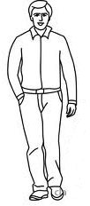father 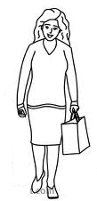mother 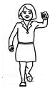sister 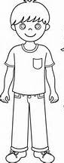brother 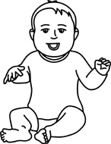baby

**LESSON 2**

Match people at home

Father Mother Sister Brother Baby

**Suggested materials**

* Real people ( father , mother, sister, brother and baby)
* Pictures
* Visual aids

Children will tell news about people at home. For example;

News news

When I went back home,

I found mummy cooking in the kitchen

**Procedure:**

Discuss with the children about people at home and their roles e.g

* Father pays schools fees
* Mother cooks food
* Sister sweeps the compound
* Brother slashes the compound

**Activity:**

Learners will match people found at home and their names.

 Baby

 Sister

 Brother

 Mother

 Father

**LESSON 3**

**Learning outcome:**

Identify people who protect and take care about me.

**Competence:**

Observes and talks about people at home and learning centre. E,g

Parents, children, uncles, nephew, daughter

Learners will copy and learn people at home.

**Suggested materials:**

* Real people
* Pictures
* Visual aids

Learners will sing a song about people at home

Father is driving ---

**Activity:**

Learners will copy and learn people at home.

|  |  |  |
| --- | --- | --- |
| father | mother | Image result for sister images black and whitesister |

**LESSON 4:**

**Learning outcome:**

Observes and talks about people at home and learning centre.

**Competence:**

Observes and talks about people at learning centre e.g teachers, nurse, school bursar, head teacher, gateman / gate keeper, librarian , rector, director, wardens and matrons

**Suggested material:**

* Flash cards showing people at school
* Visual to show people at school
* Real people

**Procedure:**

Discuss with the learners about people found at the learning centre.

Show the learners flash cards which shows people at school, if time allows they can be taken to the visual to observe.

A song about people at the learning centre

Teacher is teaching x 2

What a happy school

U can see

**Rhyme:**

Teacher, teacher x 2

Teacher is good

Teacher is smart

I love my teacher.

Activity:

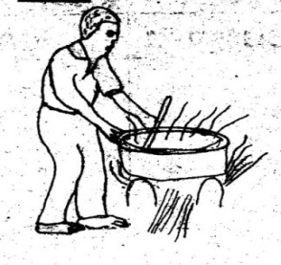Match people at the learning centre

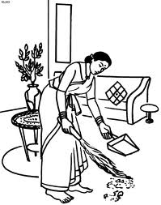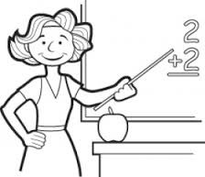

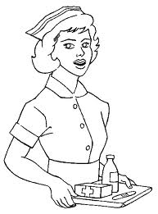

 





**LESSON 5**

**Learning outcome:**

Identifying , taking interest and observing people around me.

**Competence:**

Tells roles of people at the learning centre e.g

A teacher – teaches children

Cleaner – cleans the compound

School nurse – treats sick people (children)

**Suggested materials**

* Flash cards
* Visual aid
* Real people

**Procedure**

Discuss with the learners about people at the learning centre and their roles.

Show learners flash cards of pictures of people at the learning centre.

Recite a rhyme about people at learning centre

My school my school x 2

I love my school I love my teacher my teacher x 2

When I grow up

A teacher I will be,

To teach little girls and boys

A teacher I will be.

**Activity:**

Copy and name the people at learning centre.

|  |  |  |  |
| --- | --- | --- | --- |
| https://encrypted-tbn1.gstatic.com/images?q=tbn:ANd9GcSE6NfycjHYvdZsLvd3ReYaA1uhrMDr4F5Ipk3fuX41IPWmltujlw  teacher | ANd9GcRha3iP-S4GccQzs2VwoHgvlcDFeMBaHWMOCiILzEgUAeNJxYx0  nurse | Image result for girl images clip art black and white  pupils | ANd9GcT6nJJMTjSDIEDhflAFLzEFw8iJJIkfw1hixJhIaH-xg2sNgF7L5Q  Gatekeeper |

**LESSON 6:**

**Learning outcome:**

Identifying, taking interest and observing people around me.

**Competence:**

Tells roles of people at home and learning centre.

**Activity:**

Let the learner match the people at the learning centre to their tools used in performing their duties

 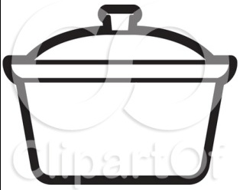

 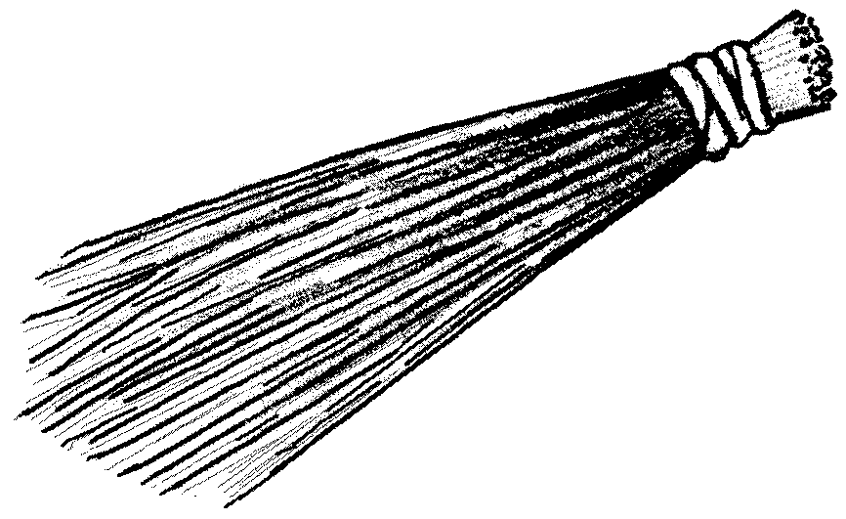

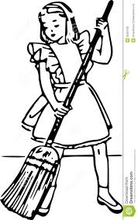 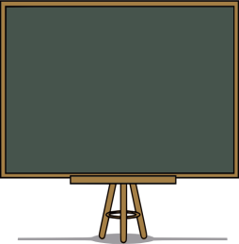

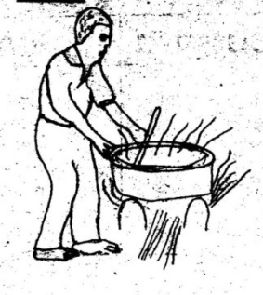

dglxasset[1]

**Learning outcome:**

Sharing and taking care of other people.

**Competence:**

Shows sympathy and empathy for others

**Suggested materials**

* Visual pictures
* Flash cards
* Real people
* Basin
* Water
* Glass
* Cold pad.

**LESSON 1**

**Procedure:**

Discuss with the learners about people who need care and help for example sick child, a child who has lost property, elders, blind, babies, pregnant mothers.

**Role play**

Call one child to act like a baby and call another child to take care of the baby and show them how they should do it.

Let the learners sing a song about babies.

Little baby

Lovely baby

Stay near me,

My baby boy

I will love you

I will pat you

Stay near me

My baby boy

**Activity:**

Let the learners observe and shade people who need help e.g babies.

Shade a baby



**LESSON 2**

**Learning outcome:**

Sharing with and taking care of other people.

**Competence:**

Shows sympathy and empathy to pregnant mother

**Suggested materials**

* Visual pictures
* Real people
* Chalk board illustration

**Procedures:**

Discuss with the learners about the pregnant mother and how to take care of her.

**Dialogue**

**Malcom:** Angel come and we play

**Angel:** No I am going to help my mother wash clothes

**Malcom:** Is she sick?

**Angel:** No, she is pregnant.

**Malcom:** Is she going to have a baby?

**Angel:** Yes please.

**Malcom:** Ok bye.

**Activity:**

Draw and shade an old person.

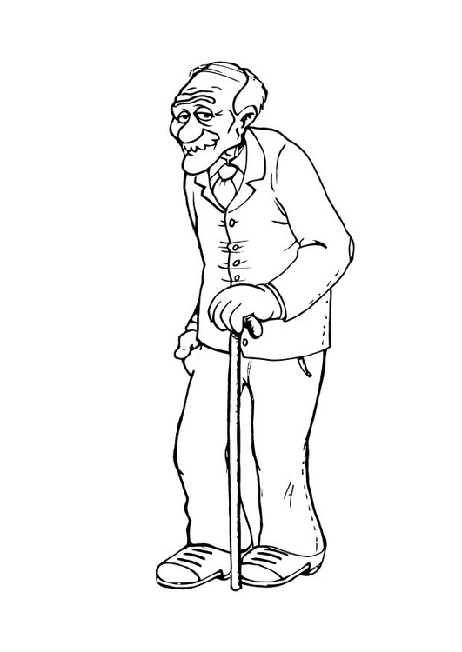

**Lesson 3**

**Learning outcome:**

Sharing with and taking care of other people.

**Competence:**

Shows sympathy and empathy for others.

**Suggested materials:**

* Visual aid
* Black board illustration

**Procedure:**

* Discuss with the learners about old people and how to take care of them .

**Recite a rhyme:**

Down in the valley

There lived an old mother,

She washes her clothes

Like this like that

Abuu a baa abara bara dush

**Activity:**

Let a learner draw and shade the pregnant mother.

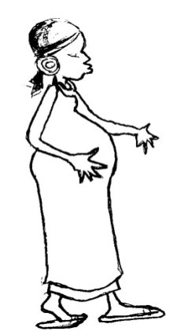

**LESSON 4:**

**Learning outcome:**

Sharing with and taking care of other people.

**Competence:**

Shows sympathy and empathy for others e.g baby, pregnant mother, old person, sick people, lame people, blind.

**Suggested materials**

* Visual aid
* Chalk board illustration
* A drawn chart showing people who need help.

**Procedure:**

Discuss with the learners about people who need help and care.

**A song**

Lame people x 2

Where are you?

Here I am, here am

How do you do?

A song about people who need help e.g

Stomach is paining x 2

Stomach is paining just now x 2

Call the doctor

**Activity:**

Let the learners circle the same pictures of the people who need help.

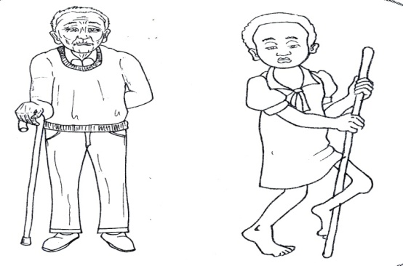  

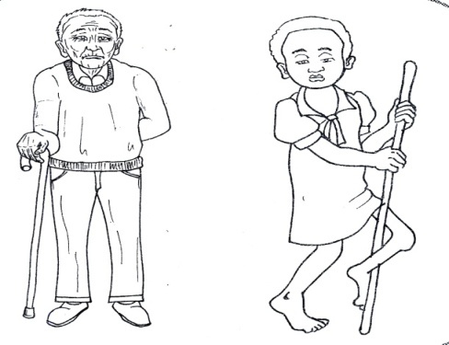  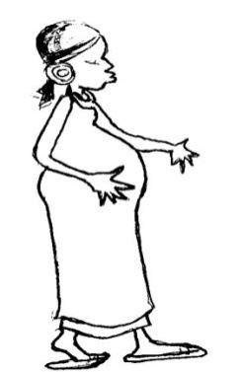

  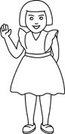

MORE PRACTICE WORK TERM 1

**LEARNING AREA I (SOCIAL DEVELOPMENT)**

**People at home. (Family members)**

Name the family members

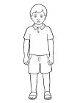___________ 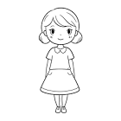__________ 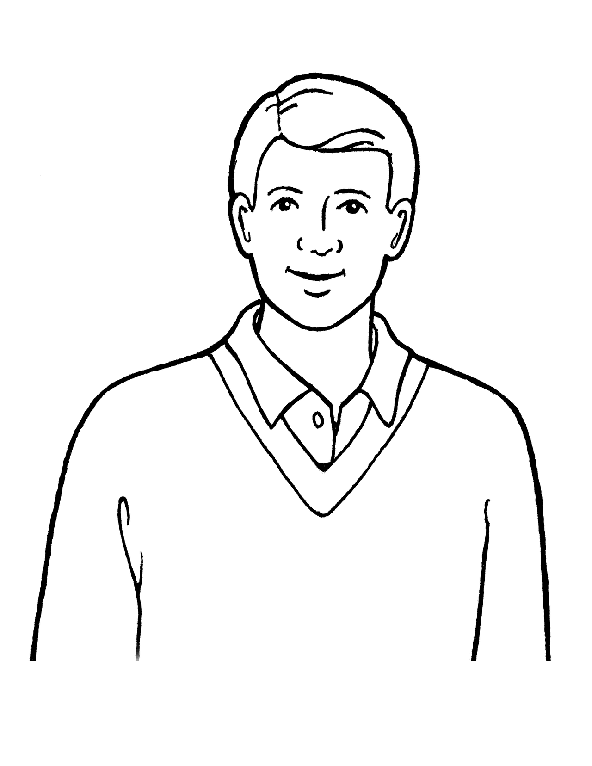 __________ 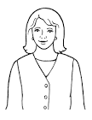 ____________ 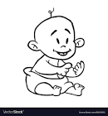____________

# (father, brother, sister, baby, mother)

**Read and draw family members**

|  |  |  |  |  |
| --- | --- | --- | --- | --- |
| Sister | Father | Baby | Mother | Brother |
|  |  |  |  |  |

**Fill in the missing letter**

m----ther br----ther b----by f---ther s-----ste

**THINGS WE USE AT HOME**

**Read and write**

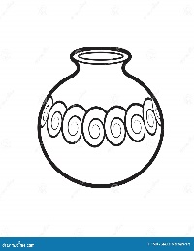pot 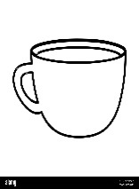 cup 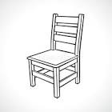 chair 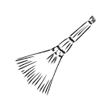broom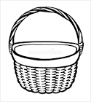 basket

spoon 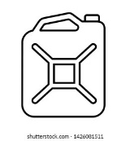 jerrycan 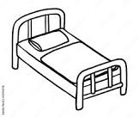 bed 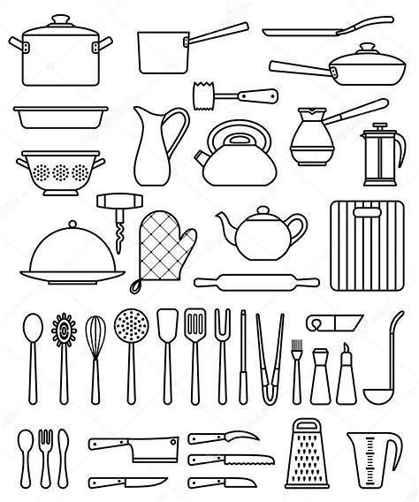 folk plate

**Name these**

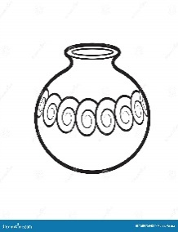________  ______  ______ ________

 _______ ______  _________

_______ _________

(bed, cup, spoon, plate, basket, chair, broom, pot, knife)

**Circle the correct word for the picture.**

 cook chair

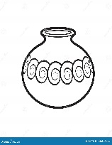 pot panga

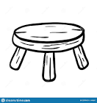 stick stool

 bed beat

 pot cup

 broom moon

**Read and draw**

|  |  |  |  |  |
| --- | --- | --- | --- | --- |
| Cup | Mat | Fork | Bed | Basket |
| Broom | Jerrycan | Knife | Plate | Spoon |

**IMPORTANT PLACES**

**Name these**

|  |  |  |
| --- | --- | --- |
|  |  |  |
|  |  |  |
|  |  |  |
|  |  |  |

(market, church, school, house, hospital, mosque)

**Read and draw**

|  |  |  |
| --- | --- | --- |
| Church | Market | Hospital |
| School | House | Garden |

**Fill in the missing letters**

g----rden sch----ol h----spital

m-----sque ch-----rch h-----use.

**THINGS IN THE CLASS**

**Copy and write**

cup 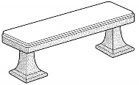bench ruler 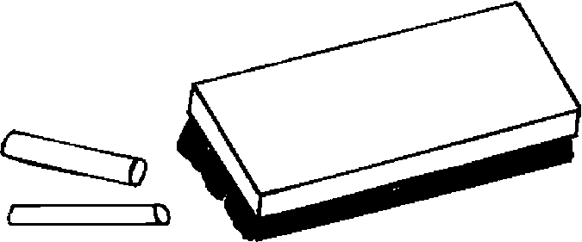 chalk box

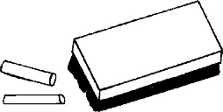duster 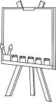 chalk board broom 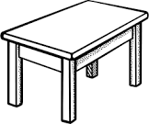 table

 chair tin pencil

**Name the pictures.**

_______ __________ ________

___________  __________ _________

_________

**Read and draw**

|  |  |  |  |
| --- | --- | --- | --- |
| Duster | Bench | Pencil | Table |
| Chair | Tin | Book | Box |
| Pen |

**Read and match**

book

tin 

pencil 

table

box 

**Fill in the missing letters.**

pencil book cup

p___ncil b___ok c__p



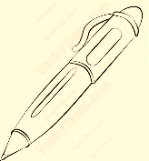table pen broom

t___ble p___n br___om

tin

t___n

**THINGS I PLAY WITH**

**Read and write**

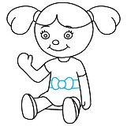doll 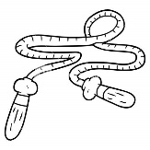rope 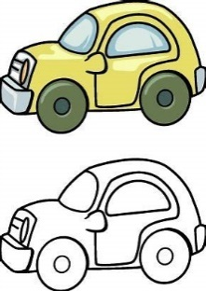toy car 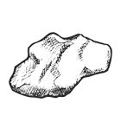stone

ball 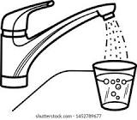water tin

**Read and draw**

|  |  |  |  |
| --- | --- | --- | --- |
| rope | ball | tin | Stone |
| doll | Toy car | water |

**Name these**

_____ ______ _______

________ _________ ___________

**SOURCES OF LIGHT**

**Name these pictures**

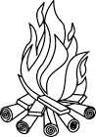___________ __________ __________

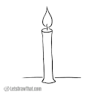___________ ____________ _________

(torch, star, candle moon , sun, fire, bulb)

**BELONGINGS**

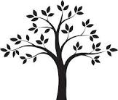- 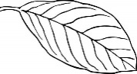 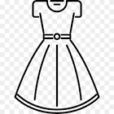  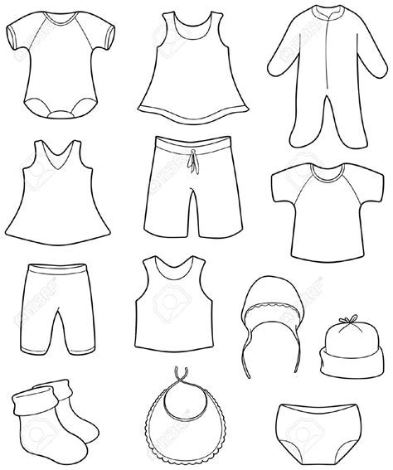

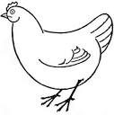 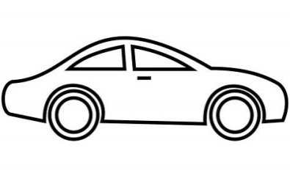

**Match to their belongings.**